CAF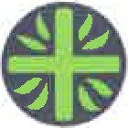D
A better world needs all of us

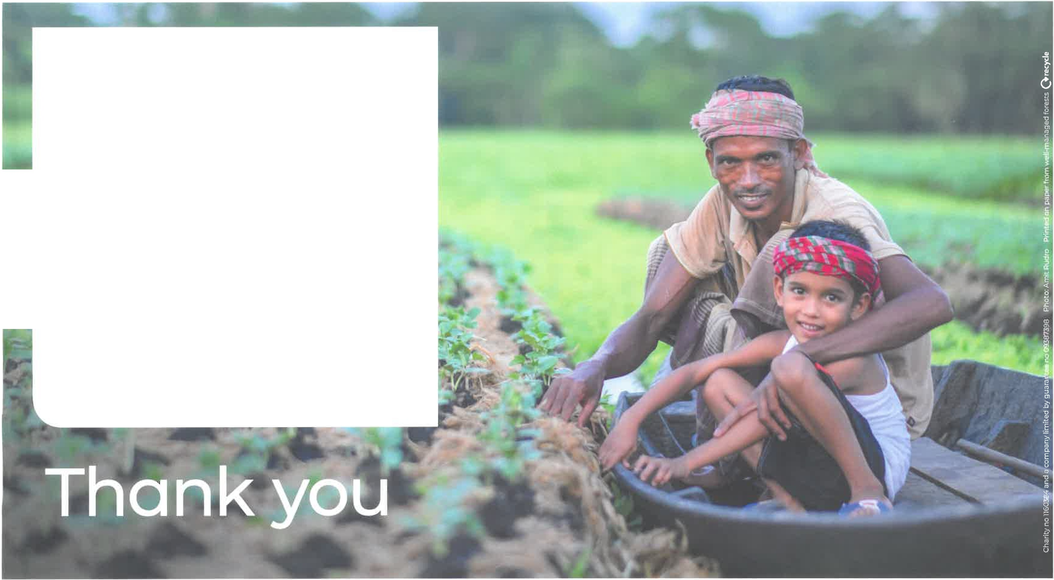

Our Lady of Lourdes RC Primary School

has raised the sum of
£350.00

to help people build a brighter future through CAFOD's projects around the world

Your fundraising will help communities like Zahidul and his son, Zunayed, in Bangladesh to create their own floating gardens.

